Pitching my campaign ideas

This document presents different games all of which I would be thrilled to run. It’s your job to find those you’d be interested in playing. Common for all of these is that they will be **themed,** meaning all player characters (“PC”) will be linked together somehow (e.g., are all kids in a gang, family, cult members etc). Once we have figured out the campaign, we’ll find an awesome theme!

Please vote for campaigns using [this survey](https://forms.gle/htVjsPN6rKBfhv4o6). In the ideal case we’ll pick a game where everyone gave a score of 3 or above. If anyone votes 1 for a game, we will very likely not play it.

I’m not really interested in getting recommendations for other games. This list is already narrowed down. Save that creative energy for when we’re making characters!

The six options are:

* 2095 Cyberpunk Copenhagen with magic, the occult, and devils
* Nordic 19th Century Mythic Horror
* Radical Remix of Descent into Avernus
* Exploring a post-apocalyptic medieval kingdom
* The Warhammer 40k game (with two options)
* Extreme horror in a supernatural modern world

All of which are explained further on the following pages.

# 2095 Cyberpunk Copenhagen with magic, the occult, and devils

*The world is neon and dust.*

*There is nothing more than the flesh. There is nothing greater than the wires. There is nothing to dream that is not sold and nothing to worship that is not made. It is a mirrorshade world of human reflections, every red hunger and every black passion worshiped in cathedrals of glass and greed. The great love their sins like children and the least want only to be great. Who could hope for more?*

**City Sandbox.**  
**Politics**: Medium  
**Roleplaying**: Low-medium.  
**Tactics**: Medium  
**Lethality**: Medium-High  
**Adventure length**: 1-2 sessions   
**System**: Cities Without Number (OSR, Very D&D like and easy to learn)

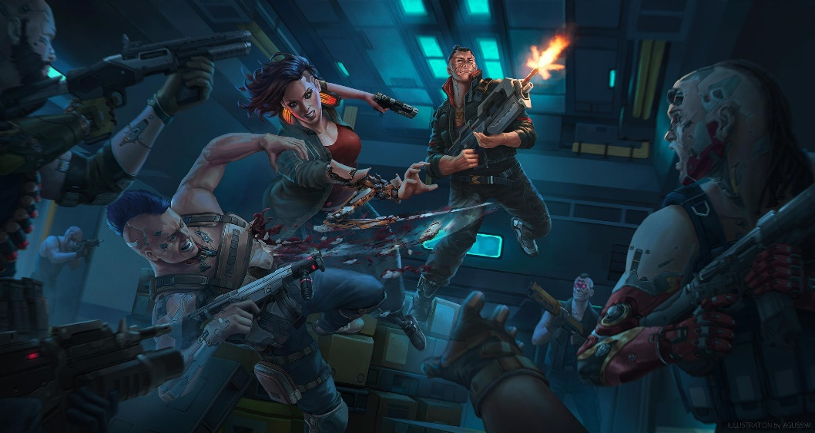**Player Buy-in**Players are highly self-directed, and PCs absolutely need to have individual goals, whether to get rich or die trying, to take bloody revenge on the corp that wronged them, or to make some haven of humanity within a hellishly commoditized world. The world will be highly reactive, and the type of games (Heist, shootdown, dungeon crawl etc) will depend on your goals.

# Nordic 19th Century Mythic Horror

*In dark forests, beyond the mountains, by black lakes in hidden groves. At your doorstep. In the shadows, something stirs. Strange beings. Twisted creatures, lurking at the edge of vision. Watching. Waiting. Unseen by most, but not by you. You see them for what they really are. Vaesen.*

*Welcome to the Mythic North – northern Europe of the nineteenth century, but not as we know it today. A land where the myths are real. A cold reach covered by vast forests, its few cities lonely beacons of industry and enlightenment – a new civilization dawning. But in the countryside, the old ways still hold sway. There, people know what lurks in the dark.*

*They know to fear it.*

**Mystery Horror**  
**Politics**: Low  
**Roleplaying**: Very High  
**Tactics**: Low  
**Lethality**: Medium  
**Adventure length**: 1-2 sessions  
**System**: Vaesen (Year Zero Engine, Easy to learn)

**Player Buy-in**Set of mysteries with no overarching plot. Big focus on PC personality and background, and the game won’t work with one dimensional PCs. Facing personal dilemmas while solving supernatural mysteries must sound fun. Will include adult themes.

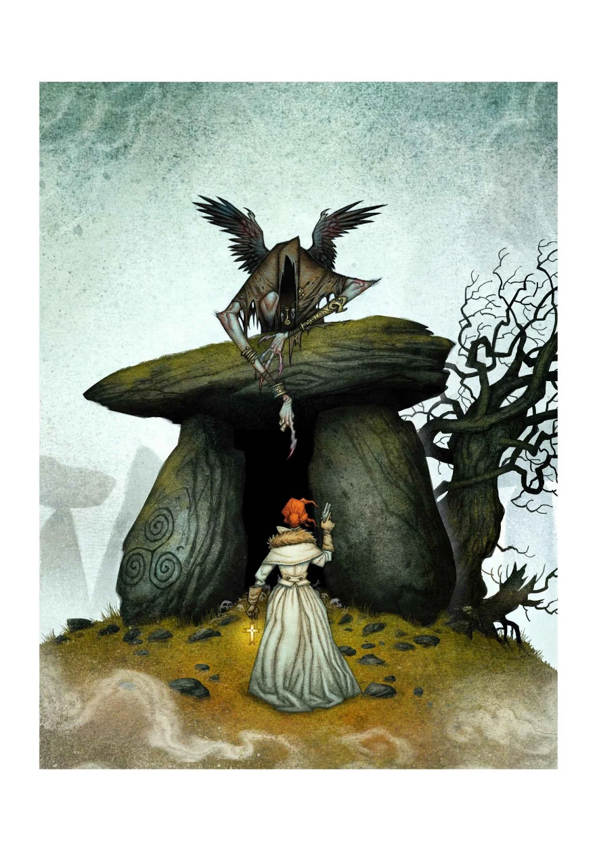

# Radical Remix of Descent into Avernus

*Welcome to Baldur's Gate, a city of ambition and corruption. You’ve just started your adventuring career, but already find yourself embroiled in a plot that sprawls from the shadows of Baldur's Gate to the front lines of the planes-spanning Blood War! Do you have what it takes to turn infernal war machines and nefarious contracts against the archdevil Zariel and her diabolical hordes? And can you ever hope to find your way home safely when pitted against the infinite evils of the Nine Hells?*

**Heroic High fantasy**  
**Politics**: Low-Medium  
**Roleplaying**: Low-Medium   
**Tactics**: High  
**Lethality:** Low  
**Adventure length**: Long campaign play  
**System**: D&D 5e with moderate homebrew changes

**Player Buy-in**You’ll be experiencing Hell and its many vices in this heroic high fantasy, classical d&d 5e campaign. It will be similar in many ways to our previous game, except this one has an overarching plot. The most combat oriented game. Your low level characters will be like Legolas sliding on a shield shooting orcs.

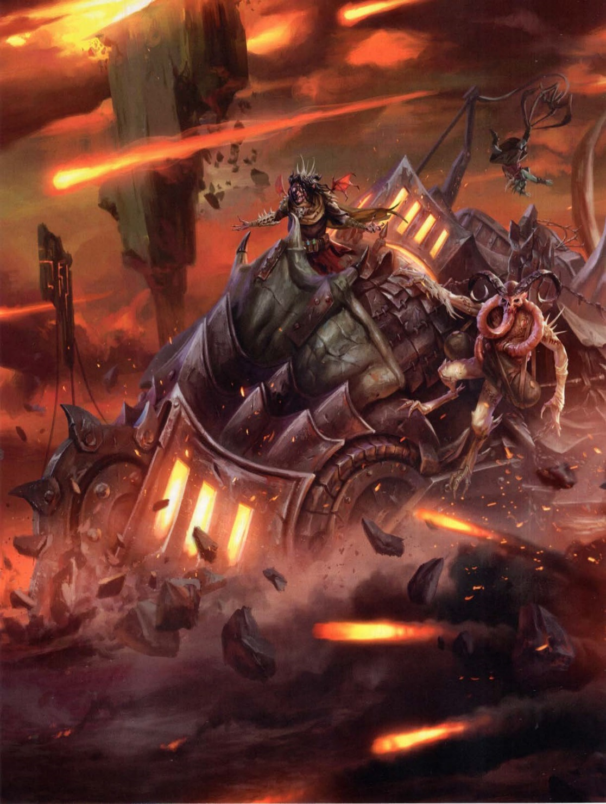

# Exploring a post-apocalyptic medieval kingdom

*In this open-world survival roleplaying game, you’re not heroes sent on missions dictated by others - instead, you are raiders and rogues bent on making your own mark on a cursed world. You will discover lost tombs, fight terrible monsters, wander the wild lands and, if you live long enough, build your own stronghold to defend.*

**Gritty hex crawl exploration**  
**Politics**: Low  
**Roleplaying**: Low-Medium  
**Tactics**: Medium  
**Lethality**: High  
**Adventure length**: Campaign Play  
**System**: Forbidden Lands (Year Zero Engine, Easy to learn)

**Player Buy-in**You will be exploring apocalypse struck medieval kingdom. You must enjoy hex exploration, hunting for food and fixing your broken weapons. Features low fantasy with risky magic and combats which are likely to grant lasting injuries if not outright death. Your characters will be like an unnamed soldier in the Lord of the Rings.

# The Warhammer 40k game

*In the 41st Millennium, warring factions from ancient civilisations and upstart empires fight endless battles across innumerable worlds. Humanity stands alone, beset on all sides by the heretic, the mutant, and the alien. There is no mercy. There is no respite. Prepare yourself for battle.*

***This campaign has two options:***

1. **Heroic action-adventure**

**Politics**: Low-Medium  
**Roleplaying**: Low-medium   
**Tactics**: High  
**Lethality**: Low-medium  
**Adventure length**: 2-4  
**System**: Wrath and Glory

1. **Mystery-investigation**

**Politics**: Medium   
**Roleplaying**: High  
**Tactics**: Low  
**Lethality**: Very high  
**Adventure length**: 2-4  
**System**: Imperium Maledictum

**Player Buy-in**The selling point here is the setting: Warhammer 40k. You don’t need to know any lore when we begin, but if you are completely new to the setting, watch [this](https://youtu.be/_rUB4mQOAiM?si=agq8sTcNDSvdv4eh) (2 min) and/or [this](https://www.youtube.com/watch?v=O7hgjuFfn3A) (13 min) video. If they don’t hype you up, this is not the game for you. In the Heroic version you’ll play characters similar to those in the Astartes short movie, and in the Investigation, you will be common citizens.

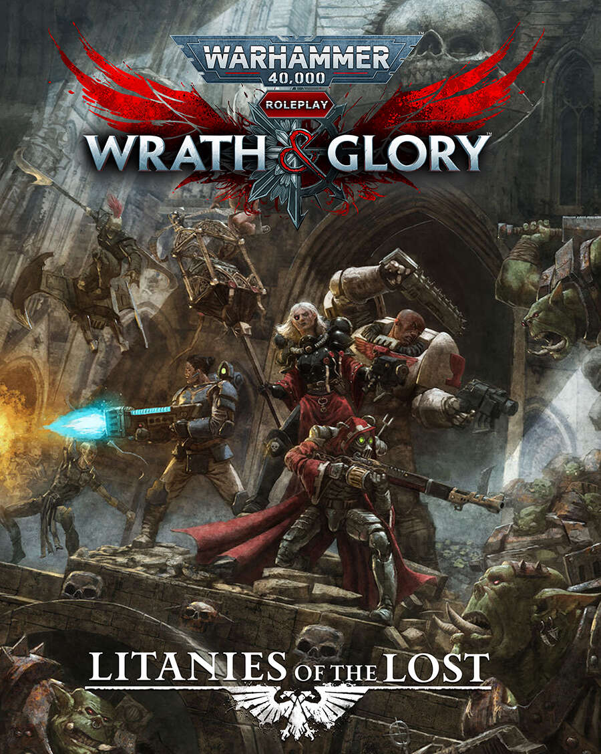

# Extreme horror in a supernatural modern world

*Mankind is trapped in an Illusion. Held captives by our prisoners. We can not see the great citadels of Metropolis towering over our highest skyscrapers. We can not hear the screams from the cellar hidden stairs take us to. We can not smell the blood and burnt flesh from those poor souls sacrificed to long forgotten Gods, in lost alleys. We feel isolated, alone, and try out utmost to stay away from the dangers, the darkness of the city we dwell in.*

**Personal Horror**  
**Politics**: Low   
**Roleplaying**: Very High  
**Tactics**: Low  
**Lethality**: High  
**Adventure length**: Short campaign play  
**System**: Kult: Divinity Lost (Powered by the Apocalypse inspired)

**Player Buy-in**You’ll delve deep into your flawed PC who is starting to see the world for what it really is. The focus is on the characters, their relationships, their mundane lives, fears, hopes as they discover everything, they’ve ever known is a lie. You won’t be a hero when you battle cultists, fallen angels and other monsters. This is not a game for everyone. It features extremely graphic, comfort-zone breaking moments, such as the following example taken from the book: “*At the end of the day, what constitutes a transcendental experience depends on the individual. Some subordinate themselves completely to another’s power and strive to become totally broken and objectified in order to attain ecstasy and truth in their utter vulnerability. Some inject heroin from filthy syringes in the slums of Johannesburg, while others rape minors in a luxurious hotel room in Bangkok. There are those who achieve insight as they mutilate their genitals in front of a webcam. “*